# JS Advanced: Exam 15 July 2018

# Problem 1. Sticky Notes (Simple DOM Interaction)

You are given the following **HTML code**:

|  |
| --- |
| notes.html |
| <!DOCTYPE **html**> <**html lang="en"**> <**head**>  <**meta charset="UTF-8"**>  <**title**>Sticky Notes</**title**>  <**script src="https://code.jquery.com/jquery-3.1.0.min.js"  integrity="sha256-cCueBR6CsyA4/9szpPfrX3s49M9vUU5BgtiJj06wt/s="  crossorigin="anonymous"**></**script**>  <**style**>  **\*** {  **margin**: 0;  **padding**: 0;  }   **body** {  **font-family**: **arial**, **sans-serif**;  **font-size**: 100%;  **margin**: 3**em**;  **background**: **#2a61f5**;  **color**: **white**;  **font-weight**: **bolder**;  }   **#sticker-list**, **#note-content** {  **margin**: 1**em**;  **float**: **left**;  **position**: **relative**;  }   .**btn** {  **padding-left**: 50**px**;  }   */*an X button style*/* **li** .**button** {  **font-size**: 18**px**;  **margin-left**: 160**px**;  **position**: **relative**;  **bottom**: 10**px**;  }    .**note-content** {  **list-style**: **none**;  **text-decoration**: **none**;  **color**: **#000**;  **background**: **#ffc**;  **height**: 10**em**;  **width**: 10**em**;  **padding**: 1**em**;  **box-shadow**: 5**px** 5**px** 7**px rgba**(33, 33, 33, .7);  **display**:**inline-block**;  **margin-right**: 20**px**;  **margin-top**: 10**px**;  }   .**text div** {  **margin**: 15**px** 0;  }   **#add-sticker** {  **padding**: 8**px** 12**px**;  **border**: **none**;  **border-radius**: 10**px**;  **color**: **#2a61f5**;  **font-weight**: **bolder**;  **font-family**: **arial**, **sans-serif**;  **background-color**: **white**;  }   **hr** {  **margin**: 0.5**em** 0;  }   **p**{  **word-wrap**: **break-word**;  }   </**style**> </**head**> <**body**> <**div class="text"**>  <**div class="title-input"**>  <**label**>Title: </**label**>  <**input class="title" maxlength="11"**>  </**div**>  <**div class="text-input"**>  <**label**>Text: </**label**>  <**input class="content" maxlength="102"**>  </**div**> </**div**> <**div class="btn"**>  <**button id="add-sticker" onclick="***addSticker*()**"**> Add new sticker</**button**> </**div**> <**div class="stickerBoard"**>  <**ul id="sticker-list"**></**ul**> </**div**> <**script src="solution.js"**></**script**> </**body**> </**html**> |

### Your Task

**Write the** **missing JavaScript code** to make the **Notes board** work as expected.

* + When **both** **Title** and **Text** are **filled** upon pressing the “**Add new sticker**” button, a new sticker should appear in the sticker board and the input fields should be **reset**. Every sticker **must** have title, text and close button. Otherwise don't create note.
  + **Between** the Title and Text content of the note you should have **separating** line.
  + When the **close** button is clicked, the sticker should **disappear** from the sticker board.

### Submission

Submit only your **addSticker** function.

### Examples

**Example of empty html:**

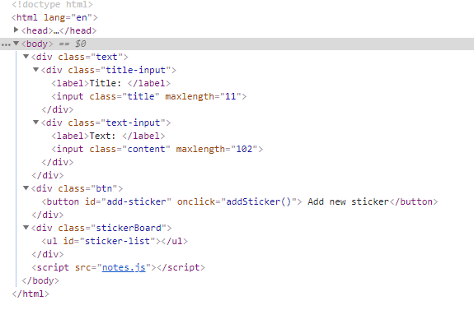

**Example of visualization and html after adding stickers:**

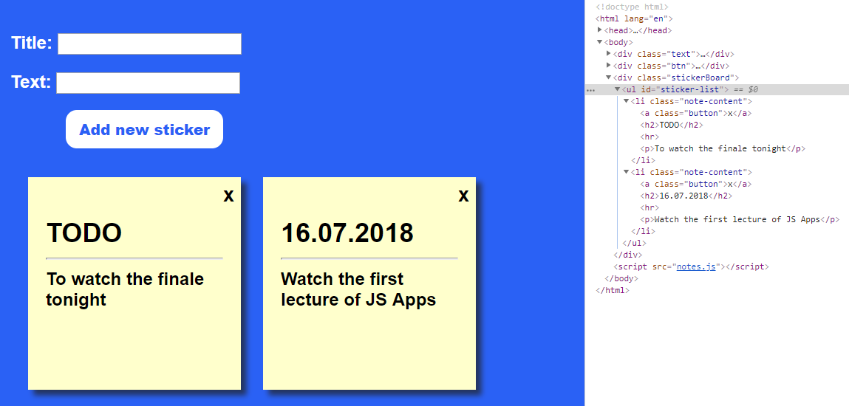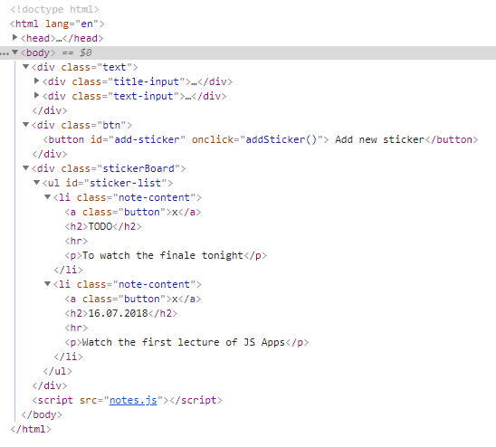

**Example after removing the first note:**

